DELAWARE VALLEY MIDDLE SCHOOL
"Where Dreams Become Reality"

CONGRATULATIONS FBLA: Future Business Leaders of America (FBLA) is a strong educational organization that provides many educational opportunities in business, leadership, and teamwork. Congratulations to our DVMS FBLA national qualifiers, Shannon O’Leary, Nadya Bermudez, Marilyn Marty, Lukas Yingling, Alexandra Tsiattalos, Anya Roessner and Adeline Murphy. These students will now move on to complete nationally in Atlanta, Georgia this June. Best wishes to each of you and great job advisor Mrs. Dennis!
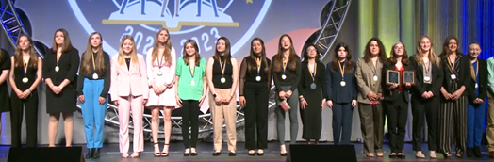
GREAT JOB DVMS FBLA

WE ALL MATTER: Autism Awareness was celebrated throughout the month of April. Each day announcements were made highlighting important facts related to autism. Mrs. Shedlauskas created a library bulletin board expressing the value of working collaboratively. Our staff continued to support Autism Awareness by wearing t-shirts throughout the month.
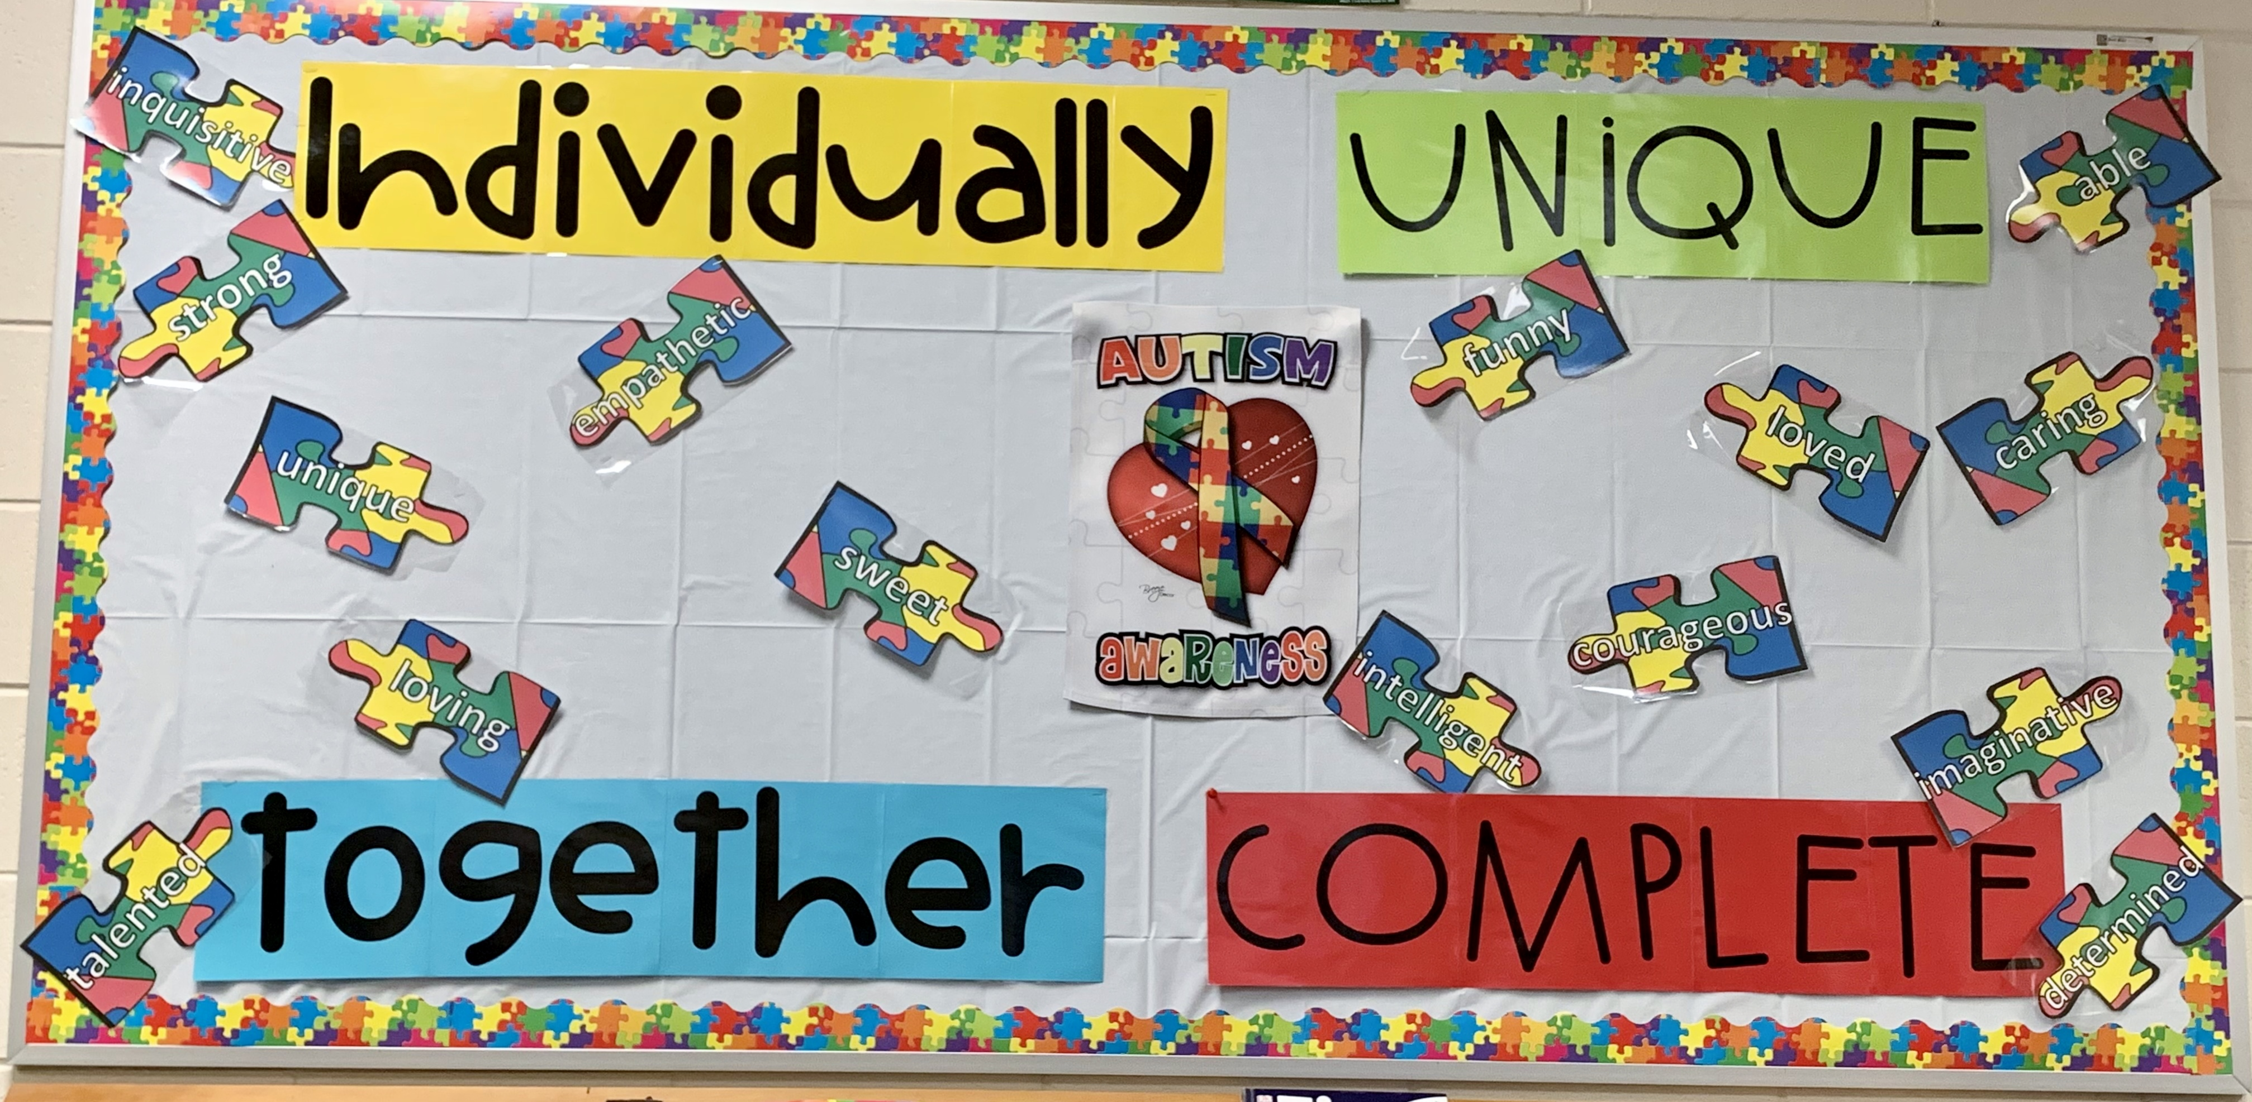

PLANNING AHEAD FOR NEXT YEAR: We will be offering our yearly – PRE-FALL – sports physical on June 7th at the DVHS nurses office starting at 8am. Please bring the attached health history and physical page along with $20.00 to sign up in the Athletic office. First come first serve!!!
Our first day of fall tryout will be August 14th. You will need a physical dated June 1st or after to tryout and it MUST be uploaded onto planeths.com.

SPECIAL GUESTS IN THE HOUSE: Take Your Child to Work Day was celebrated on April 27, 2023. This traditionally has been a favored day of the staff. We were able to have 21 guests attend a fun-filled day in the building. A nice chicken tender, mac & cheese, and cookie luncheon was prepared by the students in the Delaware Valley High School’s Warrior Cafe. From all the observed smiles, the children genuinely enjoyed the day!
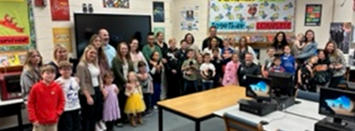
DVMS STAFF & CHILDREN

APRIL TEACHER OF THE MONTH

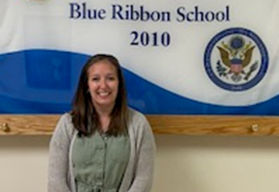
Mrs. Strattman, ELA Teacher

APRIL STUDENT OF THE MONTH NOMINEES

Fallyn Brockway Maile Butler Helaine Fitzpatrick Carina Foronda
Ever Gonzalez Posadas Devyn Jarling Jack Kahmar Olivia Castro
Lily Mangiaracina Rocco Ciarelli Peyton Copertino Zachery Spak
Isabebella Stahlman Madison Wafsman Niles Vidal Daisha Phillips

APRIL STUDENTS OF THE MONTH

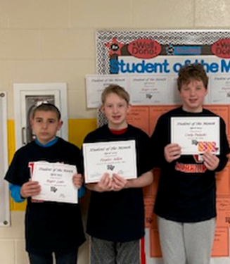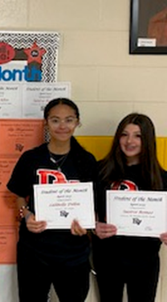
Roger Lake, Taylor Allen, Cody Pulaski, Lalibella Dillon, Saoirse Romeo

MAY HAPPENINGS

May 16 Chorus & Jazz Band Concert, 7:00PM, DVHS Auditorium
May 23 Band & Orchestra Concert, 7:00PM, DVHS Auditorium
May 23 -- 24 Algebra Keystone Assessment Grade 8, Algebra students only
May 24 Incoming Grade 6 Parent Orientation 6:00PM – 7:00PM DVMS Cafeteria
May 26 – May 29 School Closed, Memorial Day Recess

We have completed the ELA, math, and science Pennsylvania Student School Assessment (PSSA) components. Our students and staff did a very good job throughout the testing period. Several students will be completing make-up assessments the first couple of weeks of the month. The only state exam remaining will take place on May 24, and 25 for grade 8 students enrolled in algebra classes. They will be completing the Algebra Keystone Exam.

The end of the fourth marking period is also approaching. Please continue to monitor your child’s progress during the remainder of the year. There is still time remaining for one final push to increase academic performance, and for some, to avoid summer school. Please be reminded that summer school will be available on campus this summer for those students that may need to pass a class to ensure promotion to the next grade.

Enjoy the longer evenings and the beautiful weather the month will bring!

Pete Ioppolo
Principal, Ed. D.

